Geography

5.The Domains of the Earth
Imagine that you are walking on a beach, and you feel the sand beneath you. You feel the cool ocean breeze on your face as well as the water of the waves crashing on your feet. the sand is Lithosphere the water is Hydrosphere and the cool breeze that you feel is the Atmosphere. To summarize the major domains are Lithosphere, Hydrosphere, Atmosphere and Biosphere. Let us study them

Lithosphere
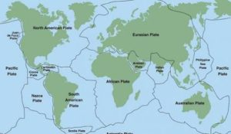
The lithosphere is a domain concerning land. When land is measured, it is measured by taking sea level as it’s base. The height of the land is also measured by denoting it as either ASL (Above Sea Level) or BSL (Below Sea Level).
For example, Mount Everest, the highest mountain on Earth is 8848 meters above the sea level and this is denoted as ASL (Above Sea Level) while Mariana Trench, deepest part on Earth is 11,022 meters BSL (Below Sea Level). These two constitute the two extremes of Lithosphere. When discussing Lithosphere we must understand the extent of the Continents.

Continents of the Earth
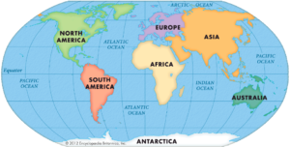
Source: Township Wiki
The Earth is divided into 7 continents. Asia, Europe, Africa, North America, South America, Antarctica, and Australia. Continents are the most important domain as they inhibit the largest number of lifeforms.
- Asia is the largest continent on Earth covering almost 1/3rd of the Earth’s land. Asia and Europe together form ‘Eurasia‘. It is followed by the continent of Africa.
- Africa is unique in its own way because it is the only continent through which the Equator, the Tropic of Cancer, and the Tropic of Capricorn pass through.
- Europe is located entirely in the Northern Hemisphere as well as some of it lies in the Eastern Hemisphere. It is bordered by the Arctic Ocean to the north, the Atlantic Ocean to the west, and the Mediterranean Sea to the south. Thus it is most suitable for fishing and harbour activities.
- North America and South America together form ‘Americas’. North America is the third largest continent on Earth. Isthmus of Panama connects North America to South America. The Northern Hemisphere is also called the Land Hemisphere because the greater part of Earth’s landmass lies in the Northern Hemisphere. Isthmus is an area of land or passage that connects two major continents.
- Australia also known as Oceania is an island continent surrounded by the Indian and Pacific oceans. It is known for its, the Great Barrier Reef, a vast interior desert wilderness called the Outback, and unique animal species like kangaroos and duck-billed platypuses which are found nowhere else.
- Antarctica is the southernmost continent and site of the South Pole, it is a virtually uninhabited and is in the completely ice-covered land. Australia and Antarctica entirely lie in the southern hemisphere.

Hydrosphere
Hydrosphere is a domain that contains water or water bodies. If we take the earth into consideration. Only 1/4th (29%) of the earth is covered in soil/land while the rest 3/4th (71%) portion is covered in water. 97% of the earth’s water is found in oceans and is not suitable for use as it is saltwater.

About the Oceans
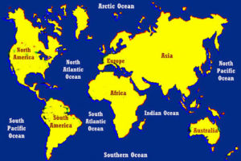
Source: sciencetrend
Oceans cover a large part of the globe. There are four primary oceans on Earth, which are Pacific Ocean, Atlantic Ocean, Indian Ocean and the Arctic Ocean.
The Arctic is a polar region located in the northernmost part of Earth. It connects to the Pacific Ocean through a Strait known as Bering Strait that passes through Russia and America. The ‘S’ shaped region between Europe, America, and Africa is the Atlantic Ocean.
The Pacific Ocean extends from the Arctic Ocean in the north to the Southern Ocean in the south. The Pacific Ocean is circular in shape and along the Pacific Ocean, there is a ‘Ring of Fire‘ meaning its an active volcanic belt. Now, the Indian Ocean extends from South Asia to Australia as well as Africa. It has gained a uniqueness due to its wind currents.

Atmosphere

Source: noaa.gov
The Atmosphere is a domain that consists of layers which are the troposphere, stratosphere, mesosphere, thermosphere as well as the exosphere. Lifeform sustains on troposphere which is the first layer of the atmosphere. The density of Atmosphere is maximum at sea level and decreases with increasing height. The atmosphere consists of 78% Nitrogen, 21% oxygen and other gases like Argon, Carbon dioxide as well as some other gases comprise 1% of the volume. 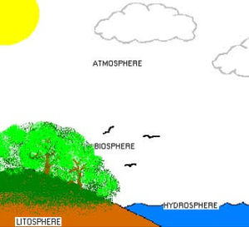

Biosphere: The Supporter of Life Forms

Source: amk.fi
Geologist Eduard Suess coined the term “Biosphere” in 1875. The biosphere is the point where all the three domains, viz. land, water and air meet as well as interact with each other. The biosphere is a zone of contact between air, water as well as land.
It is in this zone that life, that is unique to Earth exists and flourishes. The biosphere is divided into two kingdoms, Plant kingdom, and the Animal kingdom. Deforestation and pollution are rapidly damaging the Biosphere.

